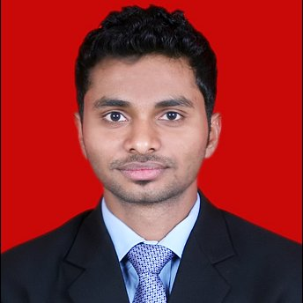
Dileep kumar N
Contact: +91 9581230705 E-mail: dilip.gcc@gmail.com
PROFILE SUMMARY
- Result oriented professional with 4 years 6 months of experience with expertise in planning & implementing ATL, BTL, DIGITAL activities, presently working as Sr. Account Manager for corporate BTL at RED FM 93.5
Skills

- Marketing Strategies & Campaigns  - Corporate Communications  - Creative Team Leadership  - Product Positioning & Branding | - Focus Group & Market Research  - Public & Media Relations  - Analytical Ability  - Digital Marketing

PROFESSIONAL EXPERIENCE

KAL RADIO PVT LTD – RED FM 93.5
Designation: Sr. Account Manager for corporate BTL - Marketing
Work Experience: from November 7th 2013 till date
Roles and Responsibilities

- Responsible for BTL Branding & Positioning of brand RED FM
- Responsible for Barter and semi barter deals
- Responsible for developing and delivering innovative media communication concepts through ATL and BTL activities.
- Handling and monitoring national and local agencies
- Designing internal and external communication materials like newsletters, press releases, fact sheets and creative.
- Formulating & implementing pre & post marketing activities for successful launching of new products / new branch inaugurations
- Responsible for performance against the predetermined KPIs at the end of every activity.
- Planning and executing various Digital media campaigns (Adwords, Facebook, email)

- Market research
- Vendor management

Agencies Handle:
- GroupM
- Jwt mindset
- Maxus
- Zenith opti media
- Lode star

Milestones Achieved:
- Star performer of the year-BTL (Expert in corporate, mall, college activations - tier 1)

PREVIOUS WORK EXPERIENCE


- Baryons Software PVT LTD

Designation: Digital Market analyst
Work Experience: from February 2013 till August 2013

Roles and Responsibilities

- Online marketing
- Online Brand building
- CPC and CPM
- Website monitoring

- British Biologicals

Designation: Business officer
Work Experience: 1 year 2 months

Roles and Responsibilities
- BTL branding
- Brand promotion through on ground diet campaigns

EDUCATION QUALIFICATION:

MBA Marketing & International Business, June 2013
- Completed 2 years full time program of MBA, in AMITY Business school from Bangalore, specializing in Marketing and I.B with an aggregate of 6.7 Percentile in the year 2013.

Awards Achieved:

- Amity’s most prestigious award “personality Enhancement award” for 2013 batch

UNDER GRADUATION:
B.sc Biotechnology-2010
- Completed 3 years full time program of Bio-tech, in GARDEN CITY COLLEGE from Bangalore University in the year 2010

Personal Details:
Technical Expertise:
Operating Systems : Windows 2000/2003/2008/XP/VISTA/Windows 7/10
Microsoft Office : MS Word, Excel, Power Point, Outlook, Access.
Website Development: Wordpress

Hobbies:
- Film making
- Travelling
- Sports

Activities:
- Member of Toast masters club

Date of Birth: 2nd August 1989

Language Proficiency: English, Hindi, Telugu

DECLARATION:
I certify that the above statements for employment are true to my knowledge. Any information check necessary to verify my qualifications can be authorized. I also agree that if I fail to meet physical requirements, or if, for any reason, I am not qualified for employment, I may not be employed and no one shall be liable for my compensation.

DATE: 31/08/2016
PLACE: Hyderabad MR. Dileep Kumar.N

